SYSTEM DESIGN
Data Flow Diagram / Use Case Diagram / Flow Diagram
The DFD is also called as bubble chart. It is a simple graphical formalism that can be used to represent a system in terms of the input data to the system, various processing carried out on these data, and the output data is generated by the system.
Data Flow Diagram:
(Admin)

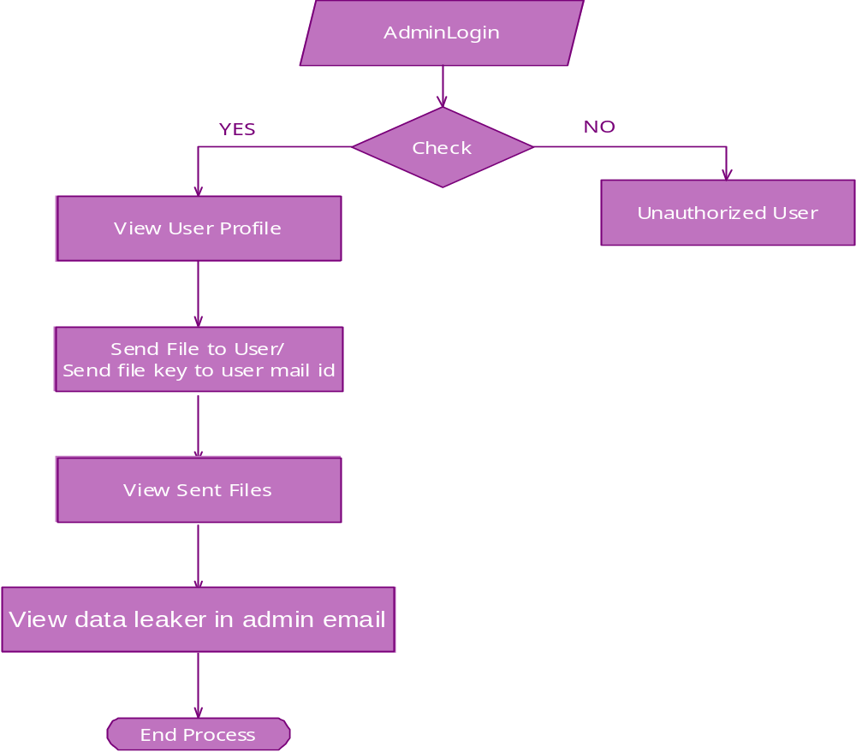

(User):

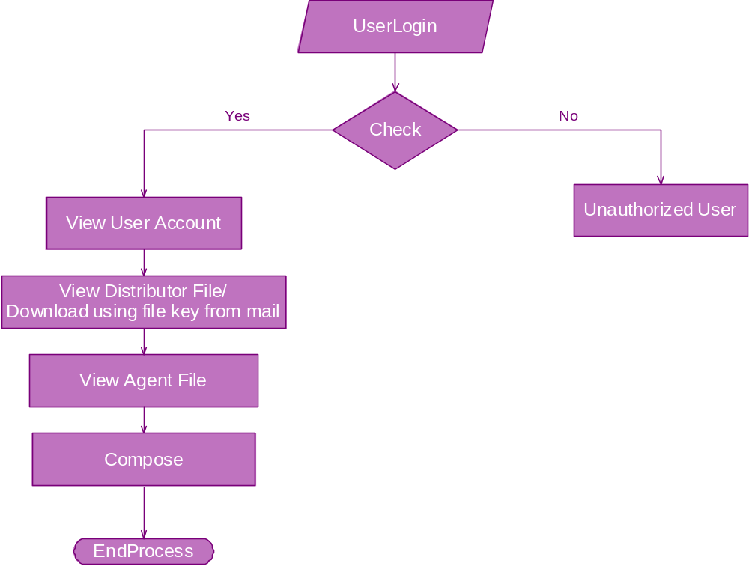

Component Diagram:
Admin:
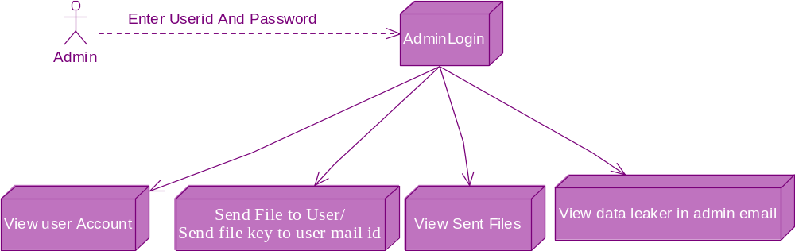

User:
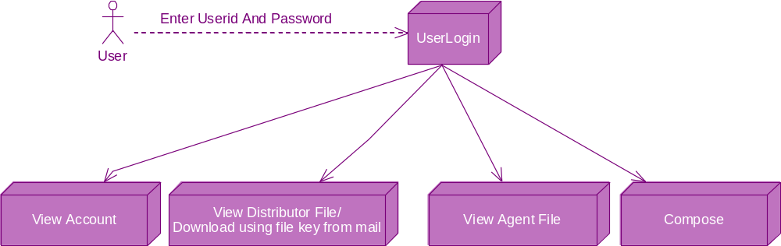

Use case Diagram:(Admin)
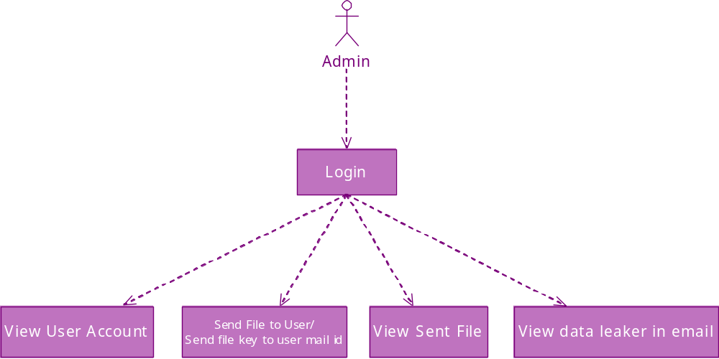

(User):
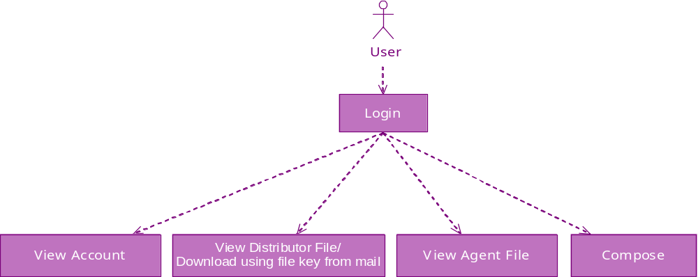

ACTIVITY DIAGRAM: (Admin)
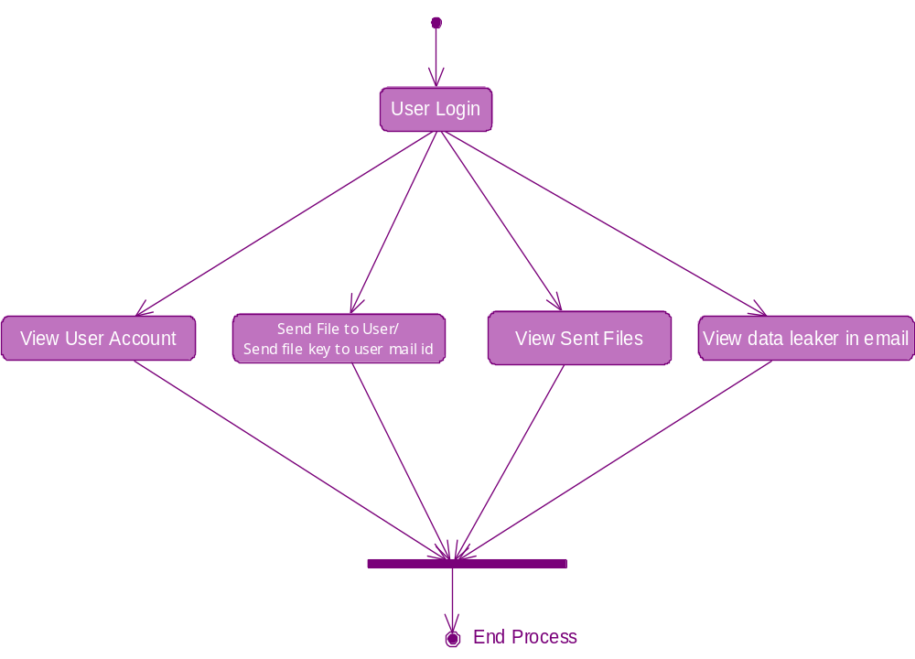

(User)
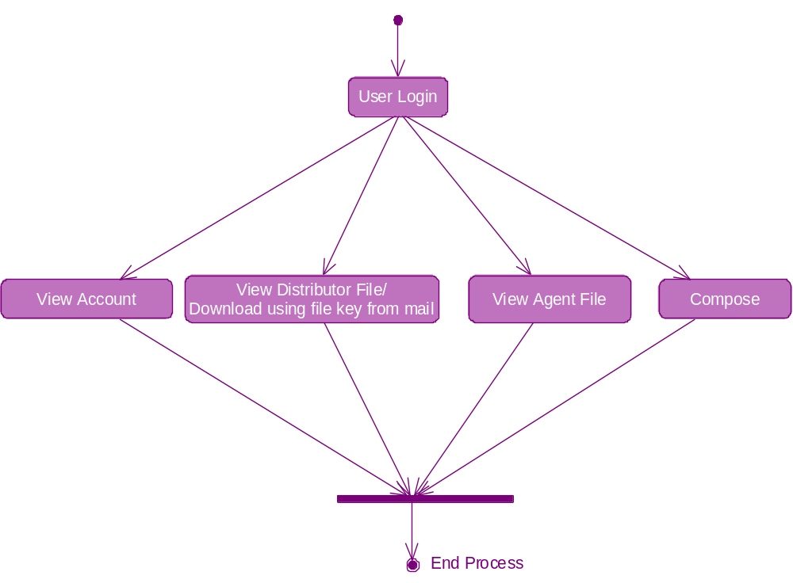

Sequence Diagram:

(Admin):
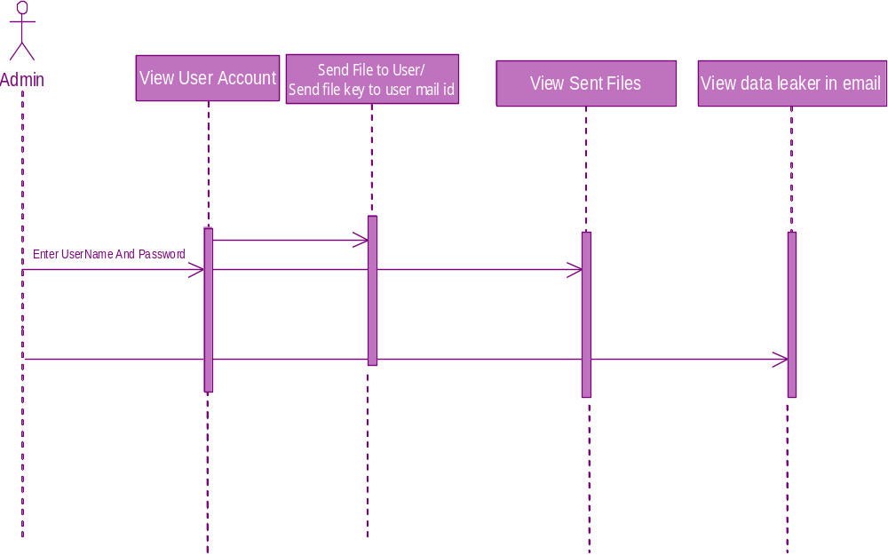

(User):

